Experiment:24 Date:18/08/2027

FAMILY TREE

Aim
To write a Prolog program to implement a family tree and determine family relationships.

Algorithm
- Start the program.
- Define parent, male, and female facts.
- Define rules for father and mother.
- Define rules for sibling and grandparent relationships.
- Query the required relationship and display the result.

PROGRAM:
parent(ravi, aseem).
parent(ravi, priya).
parent(meena, aseem).
parent(meena, priya).
parent(aseem, rahul).
male(ravi).
male(aseem).
male(rahul).
female(meena).
female(priya).
father(X, Y) :-
parent(X, Y),
male(X).
mother(X, Y) :-
parent(X, Y),
female(X).
sibling(X, Y) :-
parent(P, X),
parent(P, Y),
X \= Y.
grandparent(X, Z) :-
parent(X, Y),
parent(Y, Z).

OUTPUT:
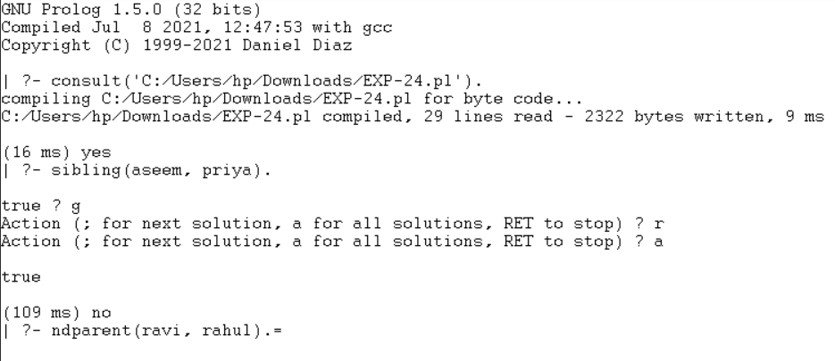

Result:
Thus, the family tree was successfully implemented using Prolog.

